# **1. Title: java Personal Finance Tracker and Budgeting App**

## **Project Statement:**

With increasing financial uncertainty and the need for better money management, individuals seek tools that allow them to track daily income, expenses, and savings goals. This application provides a personalized dashboard to record, analyze, and manage financial transactions while supporting community interaction through budgeting tips.

## **3. Outcomes:**

* Secure user authentication and role management.
* Expense and income tracking with categorized entries.
* Custom budgeting and savings goal features.
* Graphical visualization of financial data over time.
* Data export in PDF/CSV and cloud backup support.
* Optional community-based financial tips forum.

## **4. Modules to be implemented:**

* **User Authentication and Profile Management** Role-based authentication with user profile setup.
* **Expense and Income Tracking Module** Categorized input and history log of daily transactions.
* **Budget and Savings Goals** Setup and track monthly budgets and savings targets.
* **Financial Trends and Visualization** Graphs, pie charts, and bar charts to display trends.
* **Data Export and Community Forum** Export financial records and optionally interact with a financial tips community.

## **5. Week-wise module implementation and high-level requirements:**

### **Milestone 1: Weeks 1–2**

**Module: User Authentication and Profile Management**

* JWT-based user registration and login system
* Role-based access (user/admin).
* Profile creation: income, savings, target expenses.-react

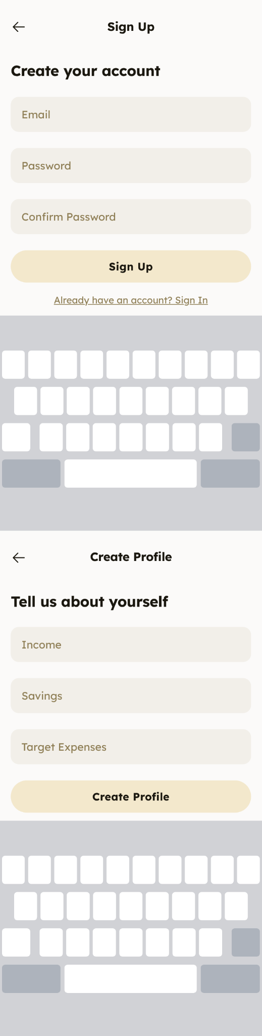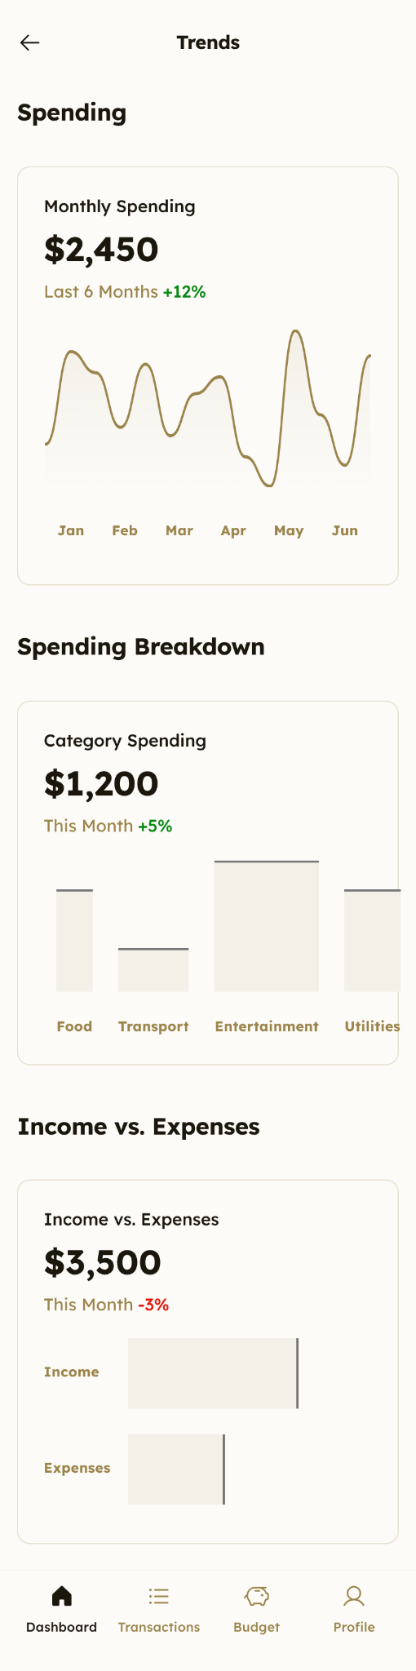

### **Milestone 2: Weeks 3–4**

**Module: Expense and Income Tracking**

* Input forms to log daily income and expenses.
* Categorization (Rent, Food, Travel, etc.).
* Edit/Delete transaction options.

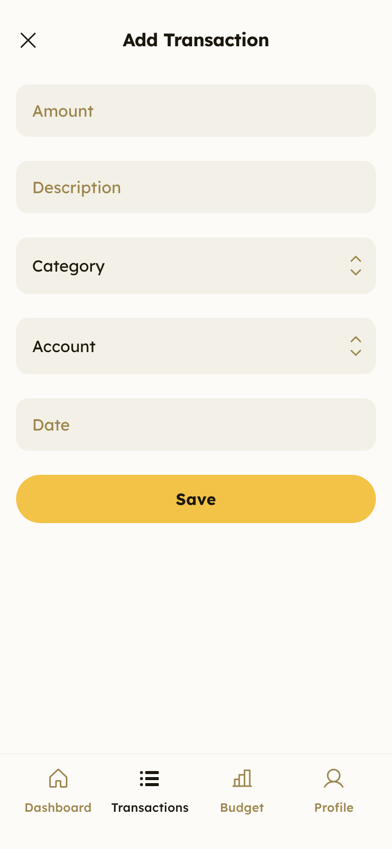

### **Milestone 3: Weeks 5–6**

**Module: Budget and Savings Goals**

* Monthly budget setting by category.
* Auto-track progress and remaining budget.
* Define and monitor savings goals.

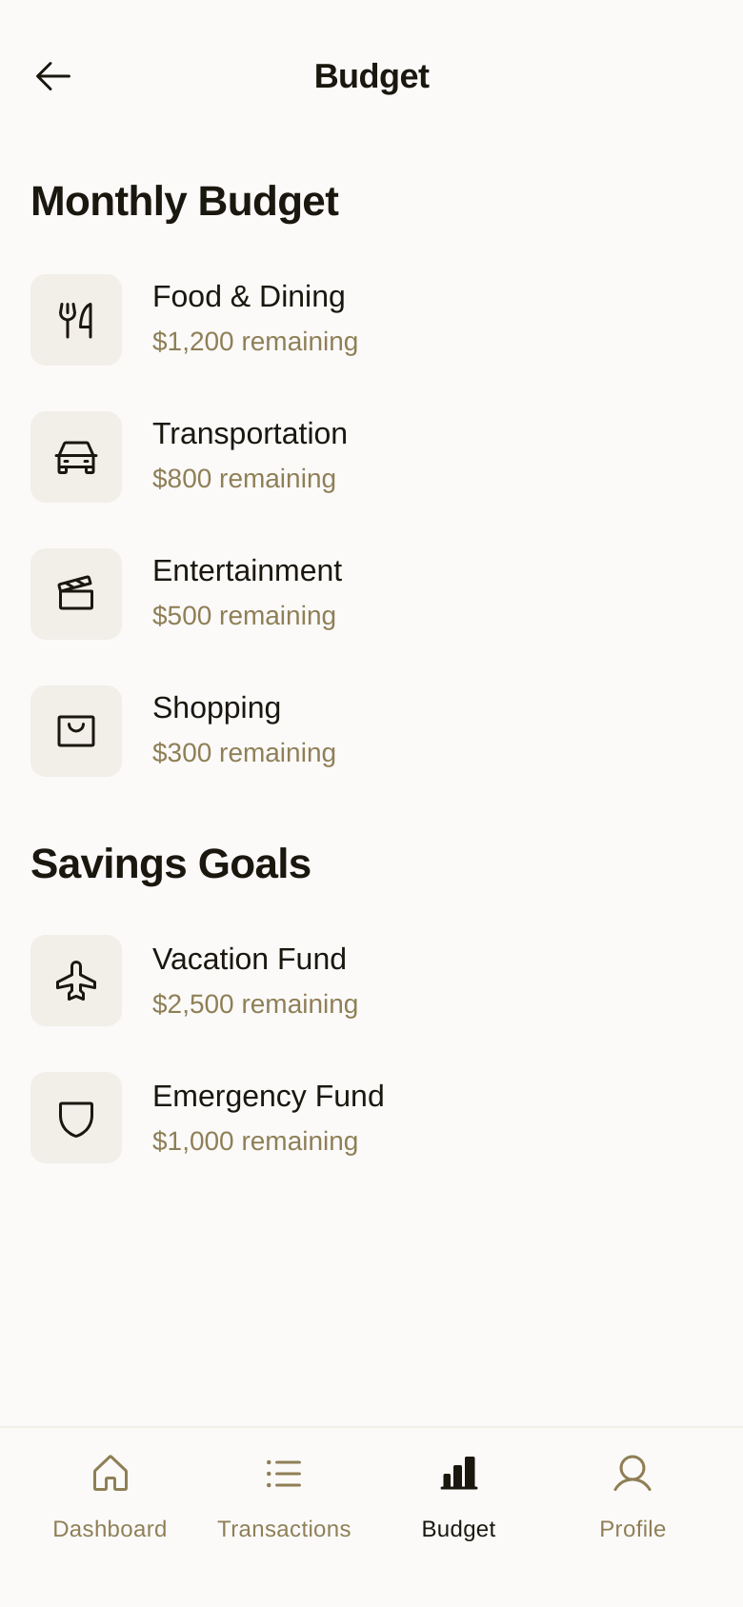

### **Milestone 4: Week 7**

**Module: Financial Trends and Visualization**

* Monthly spending comparison.
* Pie charts for category-wise spending.
* Bar charts showing income vs expenses.

### **Milestone 5: Week 8**

**Module: Export & Community Forum (Optional)**

* Export financial data to PDF or CSV format.
* Backup data to Google Drive or Dropbox.
* Financial tips forum with posts, comments, and likes.

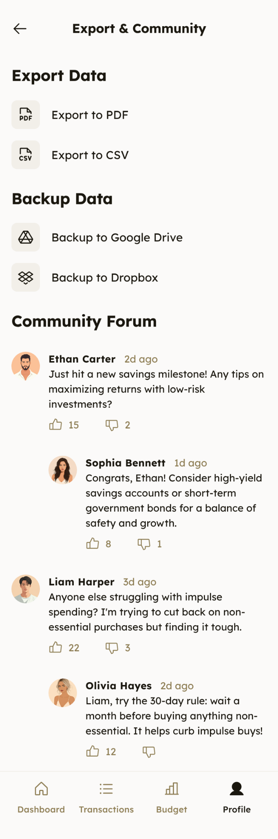

## **6. Evaluation Criteria:**

* **Week 2:** Login and profile setup fully operational.
* **Week 4:** Users can record, edit, and view categorized financial entries.
* **Week 6:** Budgeting and goal tracking functional with historical logs.
* **Week 7:** Data visualizations are accurate and easy to interpret.
* **Week 8:** Export and cloud sync implemented; forum (if present) working correctly.

## **7. Workflow diagram:**

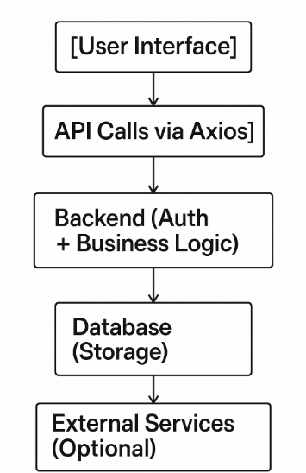

## **8. Architecture diagram:**

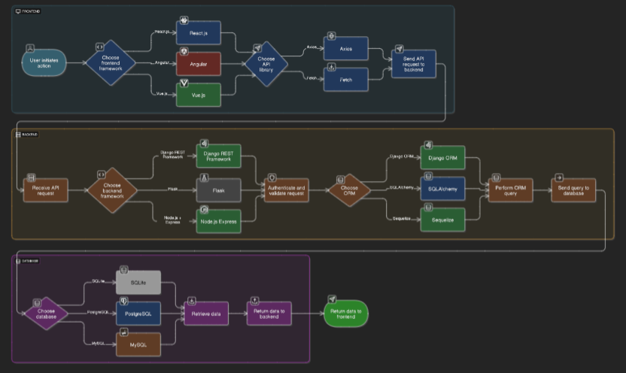

## 

## **9.Schema diagram:**

